 

FPT-aptech computer education

***Report eproject***

**Technology Product**

***Batch:*** T2307A

***Semester:*** 1

***Course:*** ePROJECT

***Group:*** 4

***Member:***

1.Dang Van Long

2.Nguyen Nhu Vu

3.Dinh Cong Minh

4.Le Quang Huy

5.Bui Minh Hieu

***Intructor:*** Nguyen Duy Hoang

MENU

**Introduction** 3

**Problem Statement** 4

**SITE MAP** 5

**USE CASE** 6

**Flow Chart** 7

**Main Screens** 11

*1.* *Home Page* 11

*2.* *About Us* 12

*3.* *Products* 13

*3.1. Mobiles* 13

*3.2. Computer* 14

*3.3. Mouse* 14

*4.* *Contact Us* 16

**Tool and Technology used** 17

**Hardware/ Software Requirements** 18

# **Introduction**

The thirst for learning, upgrading technical skills and applying the concepts in real life environment at a fast pace is what the industry demands from IT professionals today. However busy work schedules, far-flung locations, and unavailability of convenient time-slots pose as major barriers when it comes to applying the concepts into realism. And hence the need to look out for alternative means of implementation in the form of laddered approach.

The above truly pose as constraints especially for our students too! With their busy schedules, it is indeed difficult for our students to keep up with the genuine and constant need for integrated application which can be seen live especially so in the field of IT education where technology can change on the spur of a moment. Well, technology does come to our rescue at such times!!

Keeping the above in mind and in tune with our constant endeavour to use Technology in our training model, we at Aptech have thought of revolutionizing the way our students learn and implement the concepts using tools themselves by providing a live and synchronous eProject learning environment!

# **Problem Statement**

1. Problem statement:

1) The products even after being very popular in the market and the sales increasing there are some probable customers who want to view the product, learn about the features and product specifications in terms of storage technique, overall looks etc.

2) Some probable customers would also like to compare the various products within the same category.

3) The product range is not known to quite a few customers they just order on the basis of the feedback or recommendations given by their friends or colleagues and after delivery of the product it does not match either the requirements or expectations leading to wastage of time, resources and delivery costs.

4) Existing customers needing some help and support on the product after installation would have to call the oceangate office (difficult with phone lines continuously Busy) who would take their call and send the Service centre people to the place where the product is installed.

2. Requirement Specification:

The Web site is to be created based on the following requirements.

1. The Home Page should be created with proper sections, graphics and with a suitable logo
2. The site should display a menu which will contain the options for brief introduction about the various products available, location of the shop and any other information if required.
3. The information should be categorized according to the brand names of the products like if a User wants to see only Samsung product then he click on a Link/button/menu etc and he will see only That Brand products.
4. When a user selects any particular brand, a list of products for that brand will be displayed
5. A brief summary of features of individual products should be displayed on the Web Page along with the product but detailed Features should be stored in Individual Word documents which can be downloaded or viewed by the User who wishes to see the same.
6. The user should also be able to compare the various products of different as well as similar brands.
7. There should be a “Contact Us” page which will have the Address of the Company which is as follows and the mail address which when clicked will invoke the local mail client from where they can send an email.

# **SITE MAP**

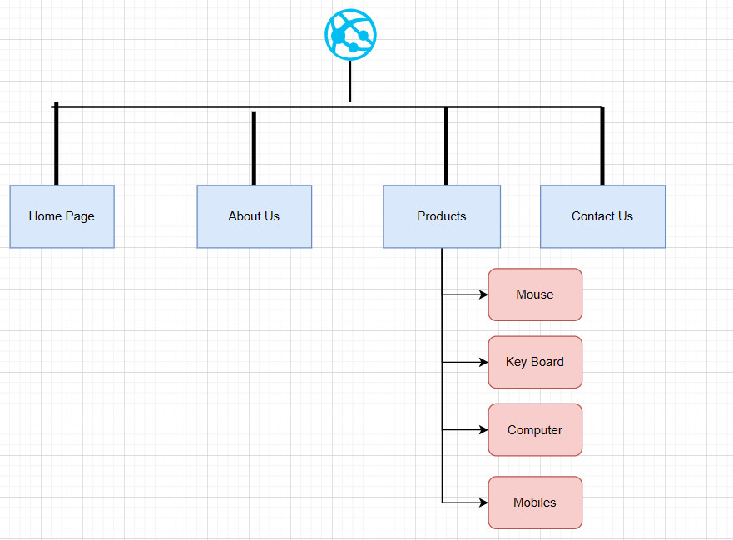

# **USE CASE**

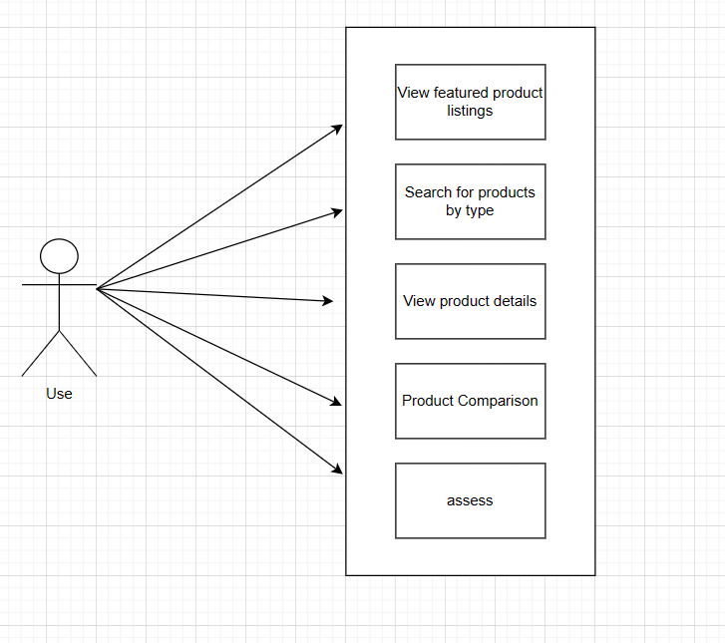

# **Flow Chart**

1. Mobiles

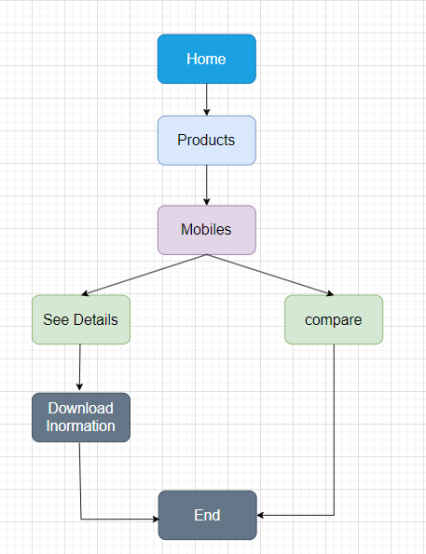

1. Computer

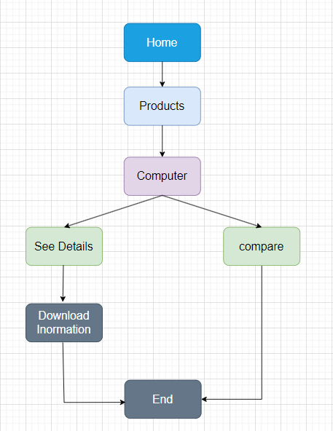

1. Mouse

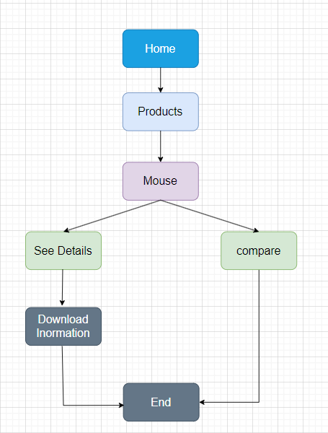

1. Key Board

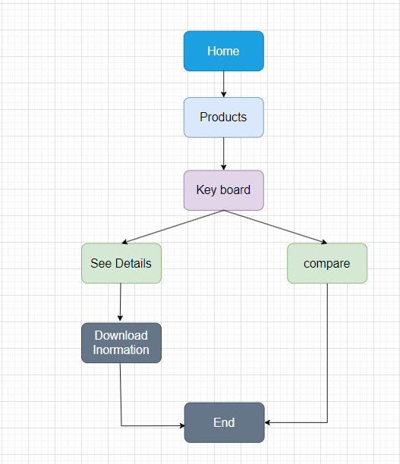

# **Main Screens**

## *Home Page*

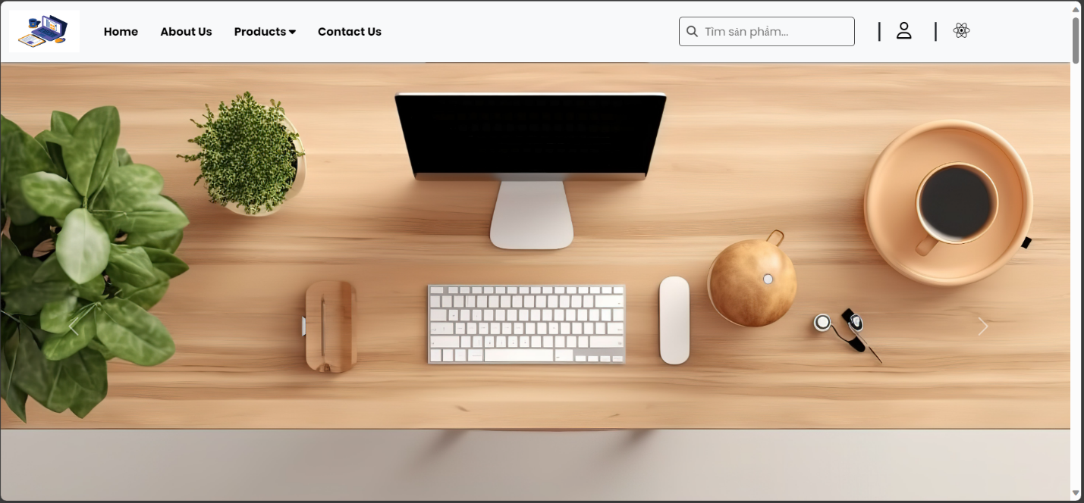

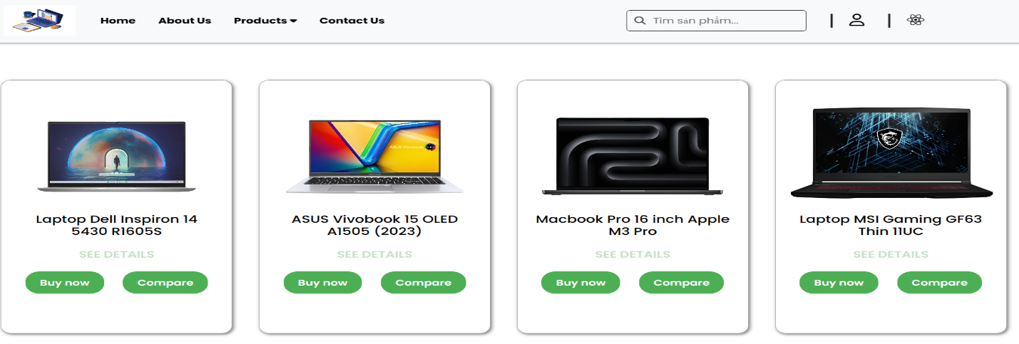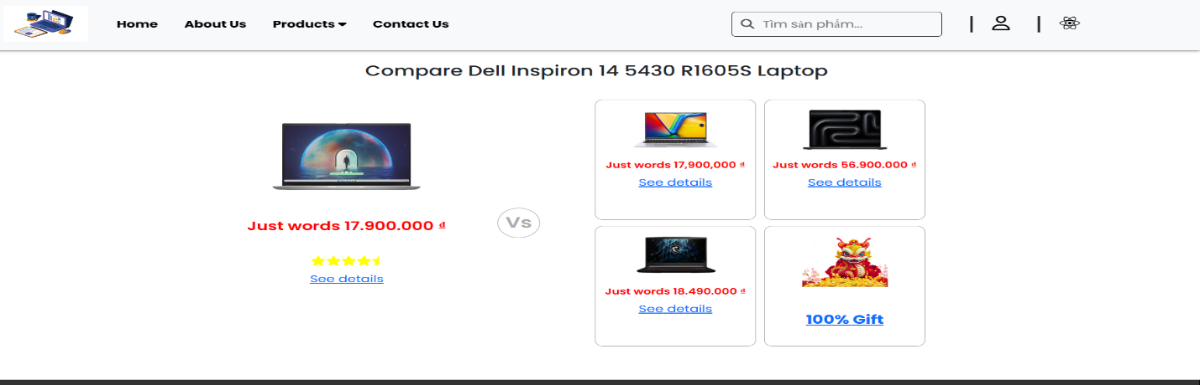

## About Us

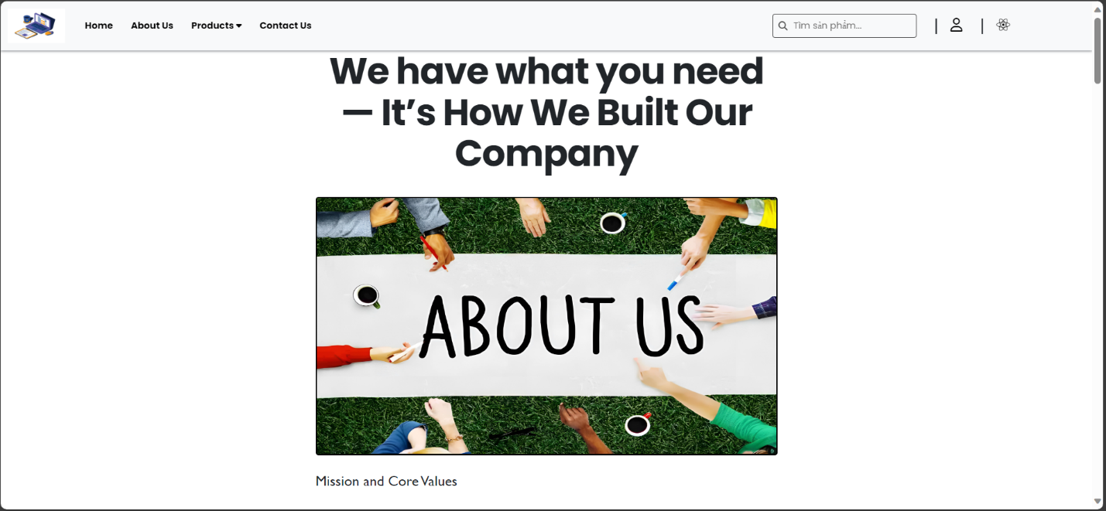

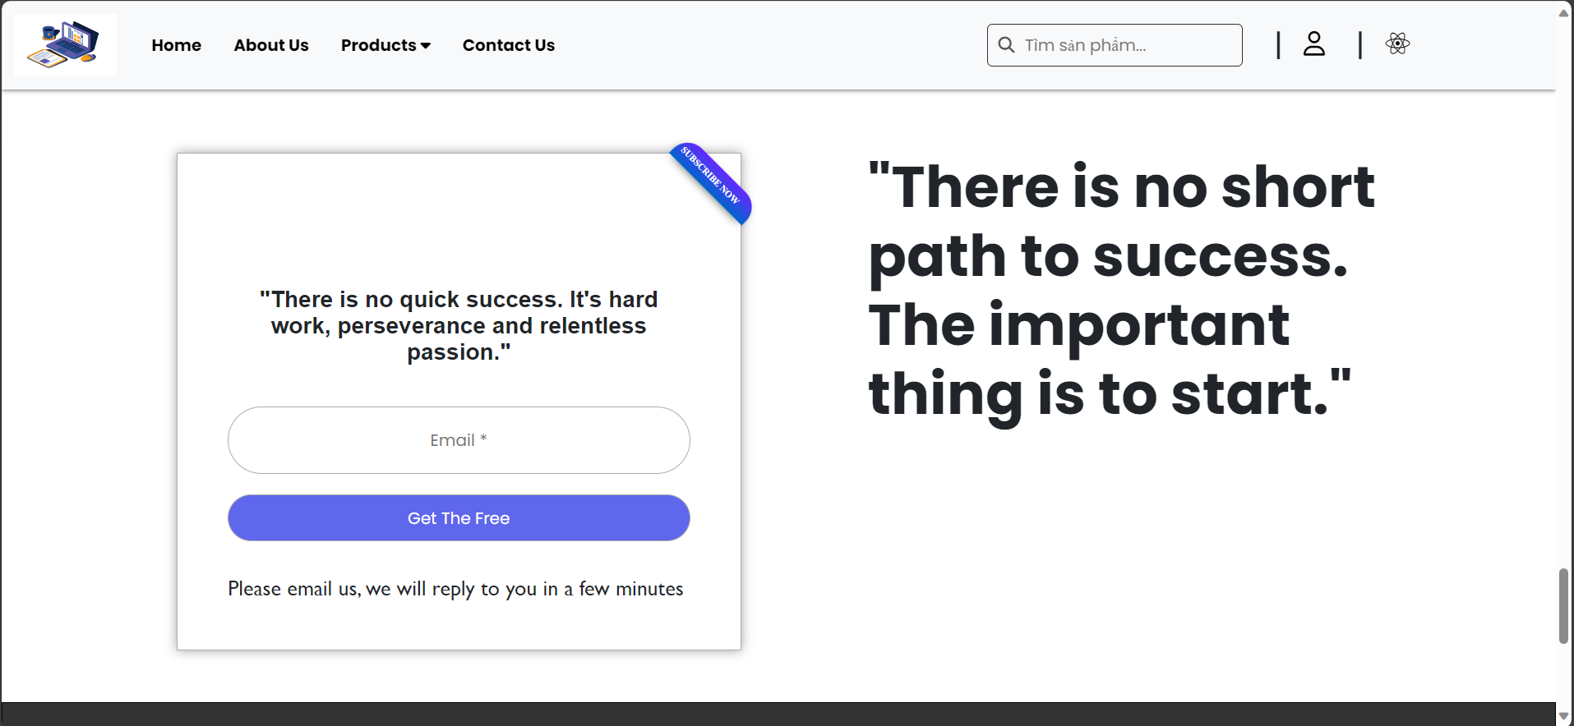

## Products

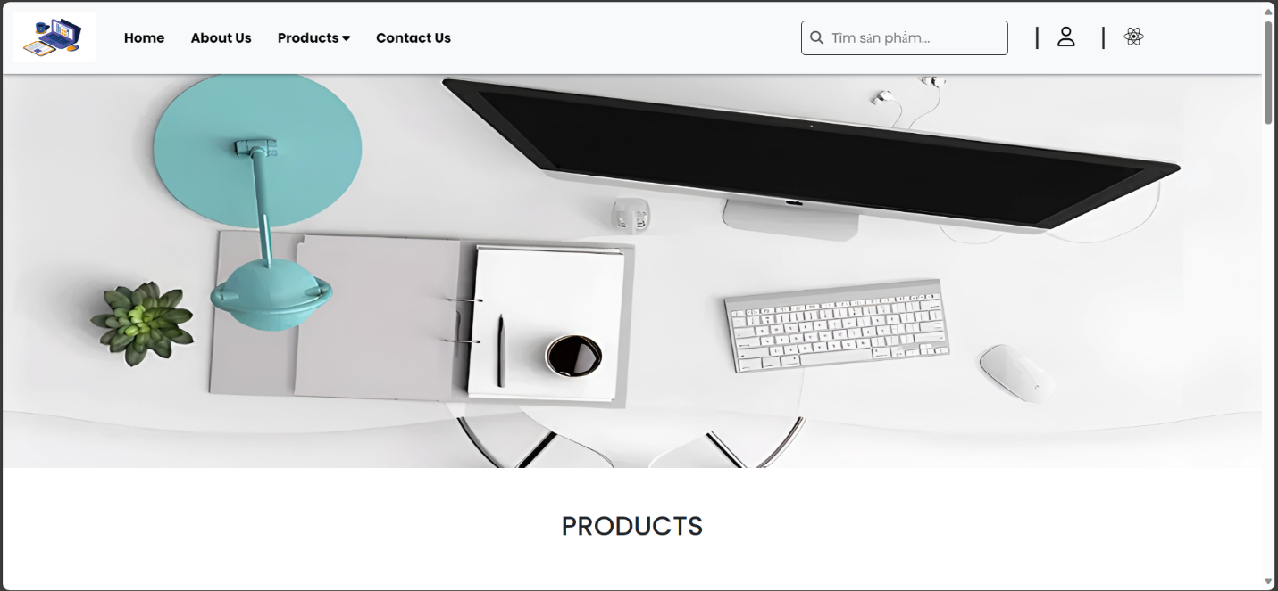

### 3.1 Mobiles

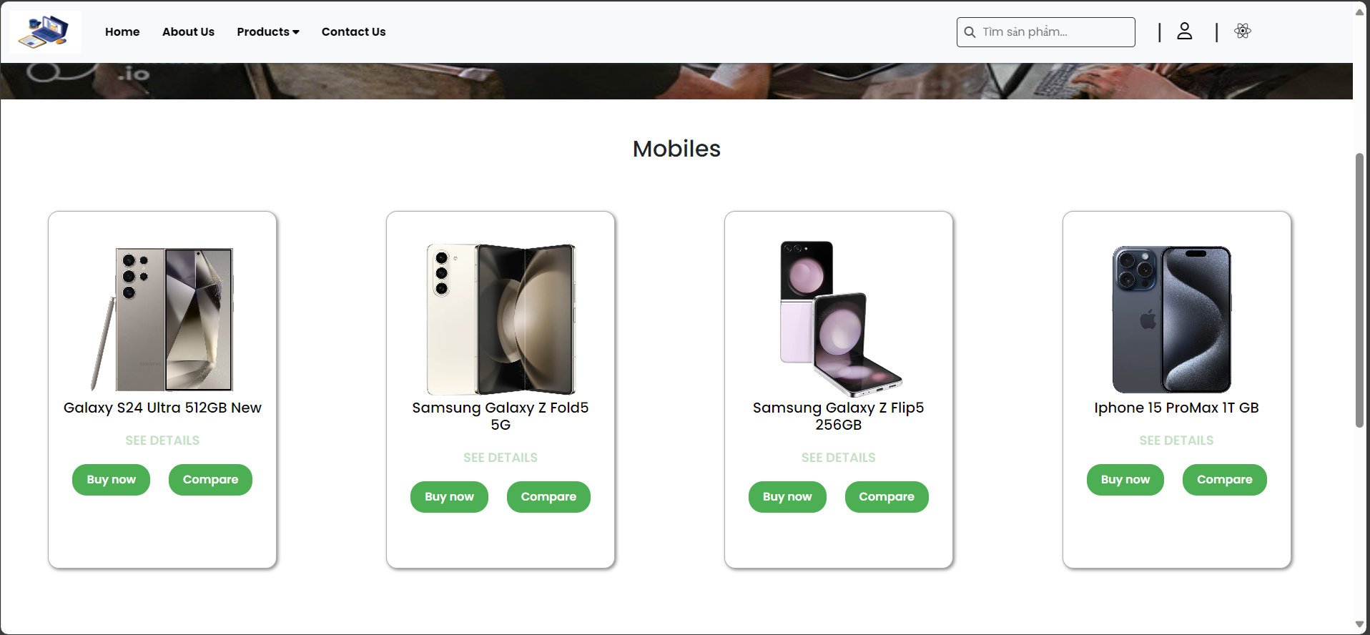

### 3.2. Computer

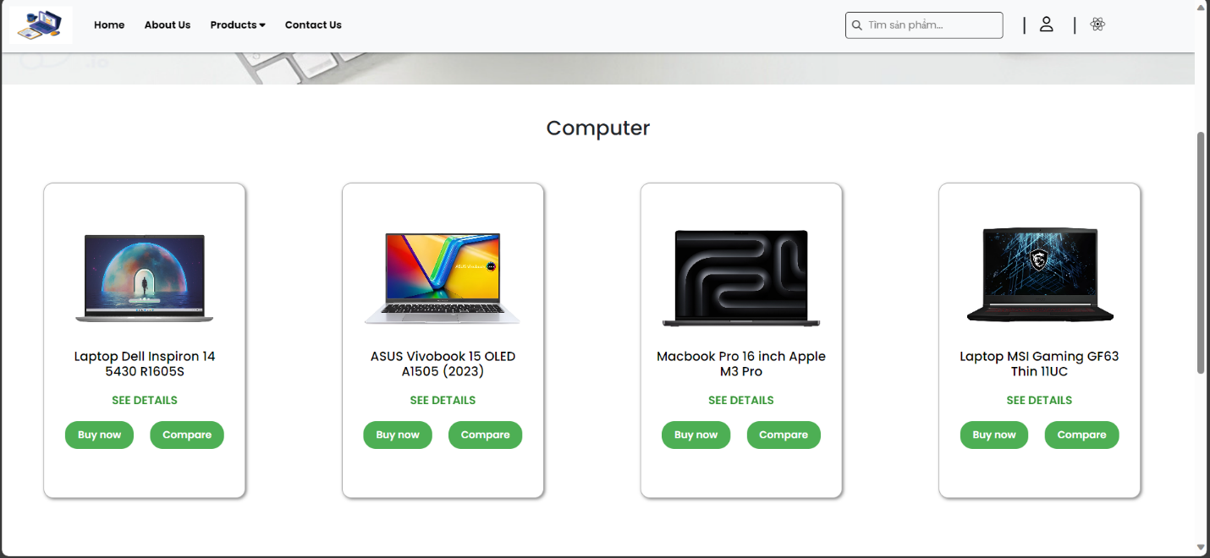

### 3.3. Mouse

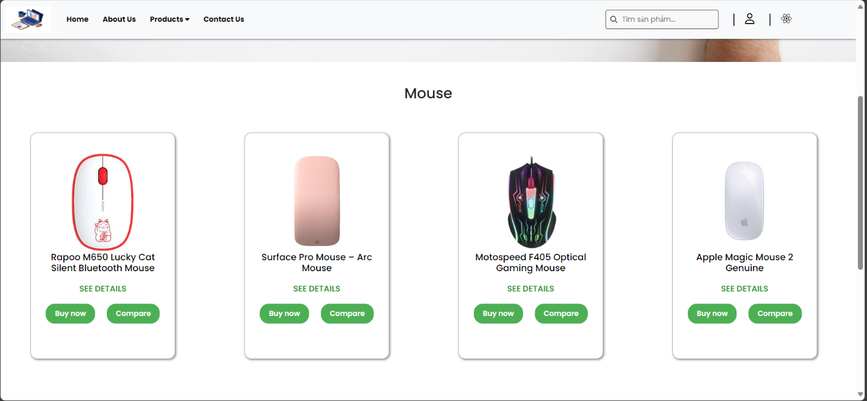

3.4. Key board

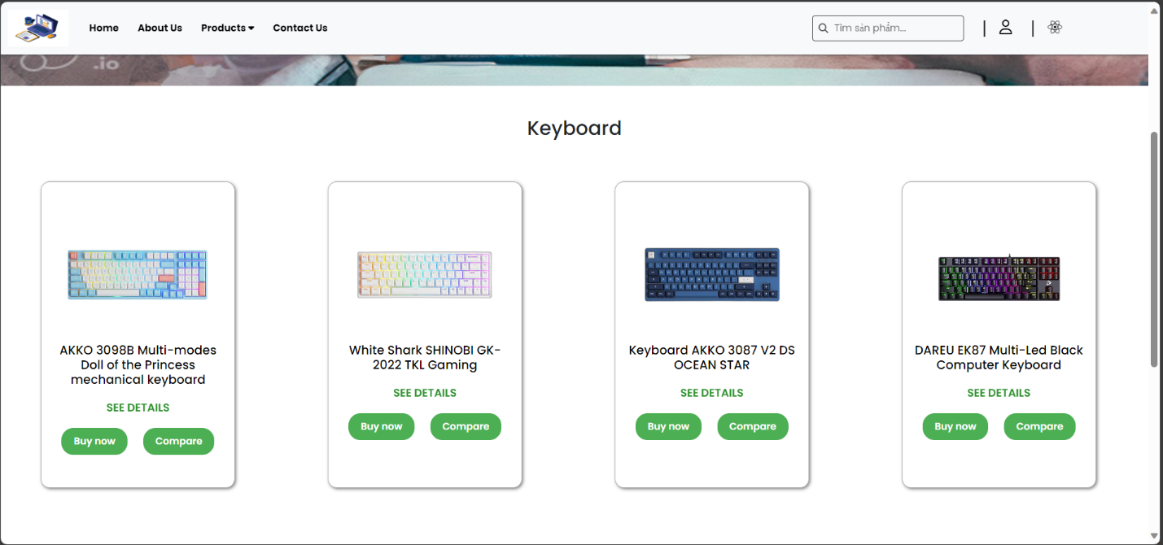

## *Contact Us*

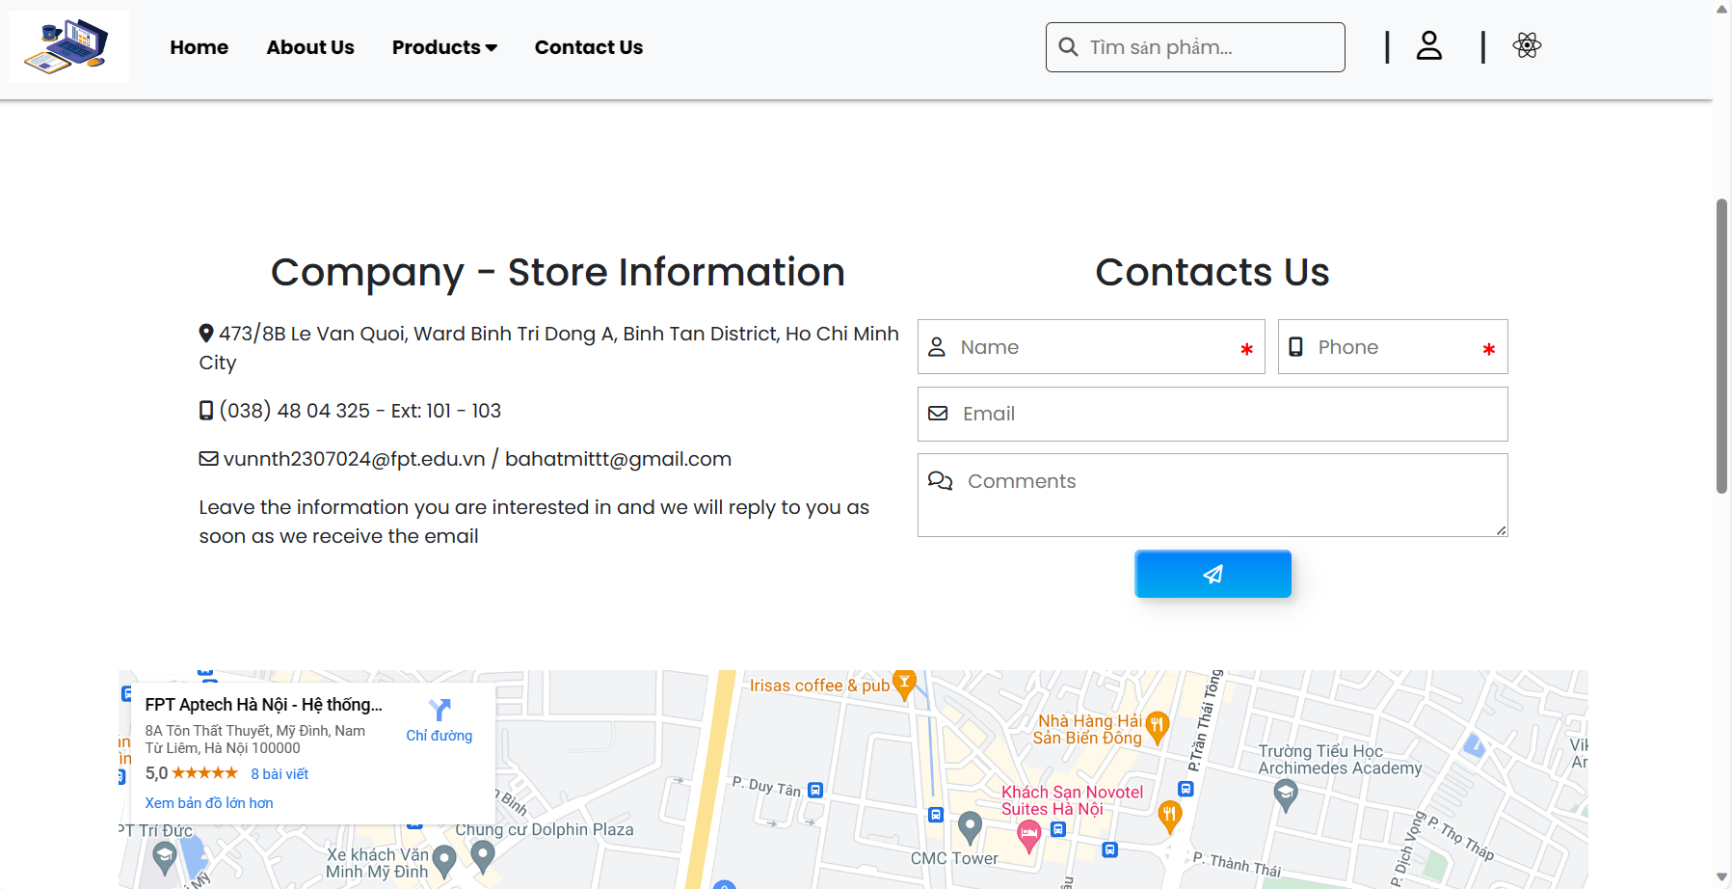

# Tool and Technology used

For this project, we are using 2 tools which are:

* Visual Code Studio
* Github

The following technologies are also being used to achieved our goals:

 

 



# **Hardware/ Software Requirements**

**Hardware**

* A minimum computer system that will help you access all the tools in the

courses is a Pentium 166 or better

* 64 Megabytes of RAM or better

**Software**

* WebStorm
* Chrome/ Firefox